[Month Day, Year]
TEXT IN THESE BOXES IS INFORMATIONAL ONLY AND SHOULD BE DELETED BEFORE SUBMITTAL
No Rise Analysis
Purpose:
This no-rise memorandum template provides an example of the engineering analysis and technical data needed to support a no-rise certificate to obtain a flood hazard permit from a local jurisdiction when the jurisdiction stipulates a 1D model should be used. A flood hazard permit is submitted and approved locally, and does not require further review by FEMA. If a no-rise is not achievable, this memorandum is not needed. Contact HQ Hydraulics for whether a Conditional Letter of Map Revision is required.

References:
(1) FEMA 44 CFR §60.3
(2) FEMA Guidance Document 79 (Section 11.2-11.4)
(3) FEMA Guidance Document 106 (Section 2.5)
(4) Local Community requirements -

INTERNAL - Review the DRAFT floodplain regulation database for local Community requirements, based on SFHA: DRAFT_Floodplain Development Regulation_Database_2022.06JUNE.30.xlsx
*Note, check Community code directly to ensure there are no additional requirements. Set up meeting with local floodplain administrator to make sure the correct models/data are being used for the no-rise comparison.

EXTERNAL - Check Community code directly to ensure there are no additional requirements above FEMA minimum standards. Set up meeting with local floodplain administrator to make sure the correct models/data are being used for the no-rise comparison.

Timing:
(1) For fish barrier removal projects: a no-rise analysis should be performed after or concurrent with Final Hydraulic Design; ensure Co-Manager concurrence on design to prevent revisions to the no-rise analysis.
(2) For other projects: a no-rise analysis should be performed after or concurrent with Final Hydraulic Design; ensure design is concurred on to prevent revisions to the no-rise analysis.
Audience: Local floodplain administrator
Contact WSDOT for additional assistance:
Luke Assink, P.E., WSDOT Hydraulics
Office Phone (360) 705-7269
Cell Phone (509) 307-6092
AssinkL@wsdot.wa.gov

TO: [Local Floodplain Administrator, Title, Phone, Email]
[Specify Local Jurisdiction]

THROUGH: Julie Heilman, State Hydraulic Engineer, 360-705-7262, heilmaj@wsdot.wa.gov

FROM: [Name, Title, Agency/Company, Phone, Email]

SUBJECT: [I/US/SR] [XX] MP [XX] [Name Creek/River] [Type of Project] Project
1-Dimensional Hydraulic Model No-Rise Analysis

Introduction
[Choose one of following:]
[(1) If the project is a fish barrier removal project:]
The Washington State Department of Transportation (WSDOT) is proposing a replacement structure for the [Interstate/United States/State] Route [I/US/SR] [XX] Mile Post (MP) [XX] [Name Creek/River], which is located [north/south/east/west] of [nearest city/town/corner], Washington (Figure 1). The existing [structure type, length, diameter, width] on [I/US/SR] [XX] was identified as a fish barrier by the Washington Department of Fish and Wildlife (WDFW) and the WSDOT Environmental Services Office (ESO) (Site ID [XXXX]) due to [specify barrier type (e.g., excessive velocity, flow depth, drop height)] (WDFW, [XXXX]). The proposed project will replace the existing structure with a [XX]-foot [type of structure]. [Describe associated project elements and reference the FHD (or other report type) (e.g., channel grading, large woody material (LWM), engineered log jam (ELJ),bank protection, etc.)] [(Add FHD or other report type Reference)]. The project plans are provided in Attachment B.
[(2) If the project is not a fish barrier removal project:]
The Washington State Department of Transportation (WSDOT) is proposing [describe type of project] for the [Interstate/United States/State] Route [I/US/SR] [XX] Mile Post (MP) [XX] [Name Creek/River], which is located [north/south/east/west] of [nearest city/town/corner], Washington (Figure 1). The existing [describe existing project features/conditions]. The proposed project will [describe proposed project]. [Describe associated project elements and reference the FHD (or other report type) (e.g., channel grading, large woody material (LWM), engineered log jam (ELJ),bank protection, etc.)] [(Add FHD or other report type Reference)]. The project plans are provided in Attachment B.

FEMA Effective Special Flood Hazard Areas
General Definitions:
Special Flood Hazard Area (SFHA)

Various FEMA SFHA Zones (Need to select “Z”, which will take you to all FEMA Zone definitions that include references to CFR zone requirements).
[Choose one of the following to describe the FEMA SFHA:]
[(1) If the project is within a FEMA SFHA:]
The project is within a Federal Emergency Management Agency (FEMA) Special Flood Hazard Area (SFHA), [specify zone(s) (e.g., Zone A, Zone AE etc.)] with [specify if there are (or are not) Base Flood Elevations (BFEs) and a regulatory floodway], as indicated in the effective FEMA Flood Insurance Rate Map (FIRM) Panel No. [XXXXXXX], dated [Month Year] (Attachment A, Figure 1). The FIRM is based on the Flood Insurance Study (FIS) for [Community Name(s)] (Community ID[s]: [XXXXX]) (FEMA, [XXXX]). [Add additional description of flood zones as necessary.]. [Check if preliminary FIRM/FIS data is available. If available, describe what was updated near the project site for the preliminary study (e.g., vertical datum conversion only, updated hydrologic/hydraulic modeling, etc.). Also add language that communication with the local Community/FEMA has taken place regarding whether preliminary or effective mapping should be used for the analysis.]. [Specify the location the flood hazard mapping data was acquired from (e.g., the National Flood Hazard Layer (NFHL) or the FEMA Map Service Center) for [Community Name(s)] (FEMA, [XXXX]). Not all projects will have digital data shown or available for download. In the case digital data is not available, it is not uncommon for the FEMA flood hazard boundaries to not align with the actual creek location. If this is the case for your project, document accordingly and contact HQ Hydraulics for further assistance. Also check for any existing Letters of Map Revision (LOMR) in non-digital areas, as previous LOMR submittals may have superseded information on the FIRM. These can be found at https://msc.fema.gov/portal/advanceSearch].
Access effective or preliminary data at the FEMA Map Service Center website. For preliminary data, search by address/place/coordinates. Move 'pin' location to project site on map. Click "Show ALL Products" link. Expand "Preliminary Products" subfolder. Download data, as needed.
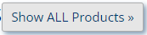
An easy way to check status and view draft/preliminary maps is here: FEMA Region X - Hazard Mitigation Plan, NFIP, Risk MAP, Declared Disasters, and Hazard Mitigation Assistance - Status (arcgis.com)
Go to the Risk MAP Status tab at the top. Click on the County. If there is a "more info" link, that will usually take you to the project page where you can view GIS Online versions of maps (check the tabs at the top again.)

[(2) If the project is NOT within a FEMA SFHA:]
The project is not within a FEMA SFHA, as indicated in the effective FEMA Flood Insurance Rate Map (FIRM) Panel No. [XXXXXXX], dated [Month Year] (Attachment A, Figure 1). The FIRM is based on the Flood Insurance Study (FIS) for [Community Name(s)] (Community ID[s]: [XXXXX]) (FEMA, [XXXX]). [Check with the local jurisdiction to see if the location is regulated as a flood hazard area. Some communities regulate floodplains that are not mapped by FEMA.]

FEMA Floodway Minimum Requirements
[Choose one of the following to describe the FEMA Floodway minimum requirements:]
[(1) If the project is within a FEMA Floodway:]
The project is within a FEMA Floodway (Attachment A, Figure 1). In order to [describe type of project] for [Name Creek/River], WSDOT will need to comply with the “No-Rise” development regulations set forth in 44 Code of Federal Regulations (CFR) §60.3 entitled “Flood Plain Management Criteria for Flood-Prone Areas”. This requires the proposed project to not result in any increase (0.00 feet) in flood levels within the community during the occurrence of the base flood discharge (e.g., 1-percent annual exceedance probability (AEP) (100-year) flood).
[(2) If the project is NOT within a FEMA Floodway:]
The project is not within a FEMA Floodway (Attachment A, Figure 1); however, the project requires a no-rise to be consistent with [specify reason (e.g., local Community requirements, Fish Habitat Enhancement Project (FHEP) program, etc.). If local Community regulation is applicable, reference Section 1.3.].

Local Community Code Requirements
INTERNAL - Review the DRAFT floodplain regulation database for local Community requirements and contact floodplain administrator about modeling/no-rise requirements, based on the mapped zones: DRAFT_Floodplain Development Regulation_Database_2022.06JUNE.30.xlsx
*Note, check Community code directly to ensure there are no additional requirements

EXTERNAL - Check Community code directly to ensure there are no additional requirements above FEMA minimum standards and contact floodplain administrator about modeling/no-rise requirements.

Contact WSDOT for additional assistance:
Luke Assink, P.E., WSDOT Hydraulics
Office Phone (360) 705-7269
Cell Phone (509) 307-6092
AssinkL@wsdot.wa.gov

[Specify Community Name(s), code section(s) XX.XX.XX, and requirements (e.g., the proposed project must not increase water surface elevations by more than X.XX feet, requires compensatory mitigation, etc.). State that local Community code requirements will govern, if more stringent than FEMA minimum criteria; reference Section 1.2].
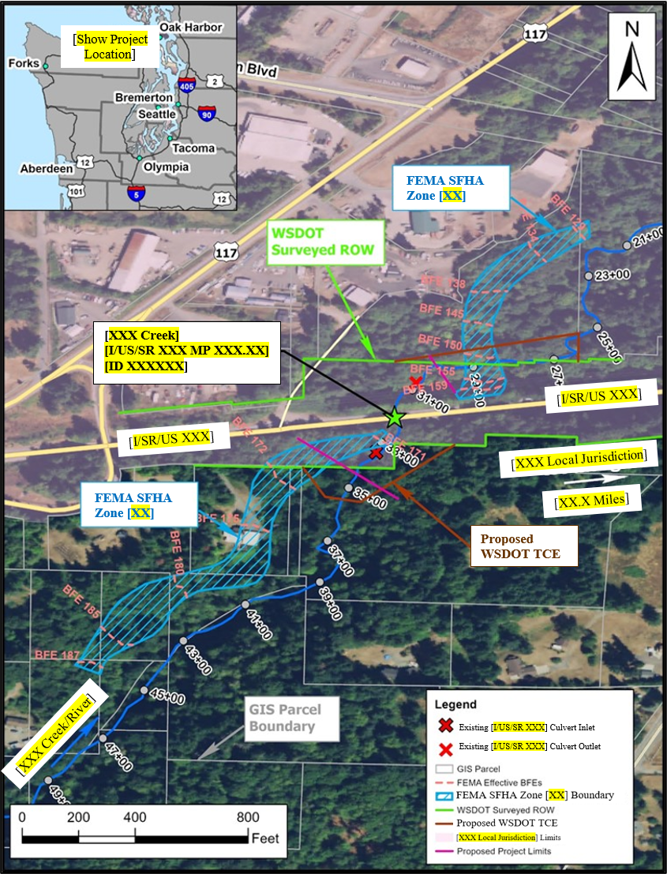
Provide Figure with same features as example.
If not in a FEMA SFHA, no need for FEMA data as shown.

Please note this example is to demonstrate when FEMA SFHA data may not align with the creek or topography. Not all projects will have digital data shown at the FEMA Map Service Center or available for download at the National Flood Hazard Layer website. In the case digital data is not available, it is not uncommon for the FEMA SFHA Zone boundary to not align with the actual creek location. If this is the case for your project, document accordingly and contact HQ Hydraulics for further assistance.

If survey ROW is not available, utilize available parcel data.

If temporary construction easements (TCE) are not needed, no need to be shown. If TCE is needed, show proposed limits and coordinate with PEO.

Figure 1 [I/US/SR] [XX] MP [XX] [Name Creek/River] [Type of Project (e.g., Culvert Replacement)] Project Site Data

No-Rise Analysis
Important for designer to coordinate with local community to find out if no-rise should be based on effective or existing conditions and whether the floodplain and/or floodway models need to be analyzed. If the local community has no preference, designs will be based on existing conditions using the floodplain model.
In accordance with [select FEMA and/or Community guidance (e.g., 44 CFR §60.3, FEMA Guidance Document 79, FEMA Guidance Document 106, Community Name(s)/code section(s) XX.XX.XX, etc.)] requirements for conducting no-rise analyses, [specify WSDOT or firm name] completed the following technical tasks for the [describe type of project] along [Name Creek/River]:
- Performed an assessment of the project site.
- Compiled [describe available data (e.g., effective FIRM/FIS data, preliminary FIRM/FIS data, topography, hydrologic data, etc.)].
- Developed hydraulic conditions models, including: [describe conditions models used in the no-rise analysis (e.g., duplicate effective, corrected effective, existing conditions, proposed conditions)].
- Compared [describe comparison analysis (e.g., proposed to existing/effective conditions water surface elevations)].
- [Floodway analysis, if applicable].
The purpose of the no-rise analysis is to show that the proposed project does not cause a rise [describe rise requirement (e.g., of more than X.XX feet) and reference appropriate Section(s) (e.g. Section 1.2 and/or Section 1.3)] in water surface elevation between the [describe analysis (e.g., proposed and existing conditions)]. These tasks are discussed in detail in the following Sections 2.1 through 2.4. All elevations specified in this memo are referenced to the NAVD88 vertical datum.

Site Assessment
[Describe project site existing conditions; reference Figure 2]. [Describe existing project features/conditions (e.g., X-foot corrugated metal pipe (CMP) with metal wingwalls that conform to the surrounding ground, X-span bridge, bank protection, habitat restoration, etc.)]. [Describe stream conditions upstream and downstream of the project site; reference Figure 3 and Figure 4].
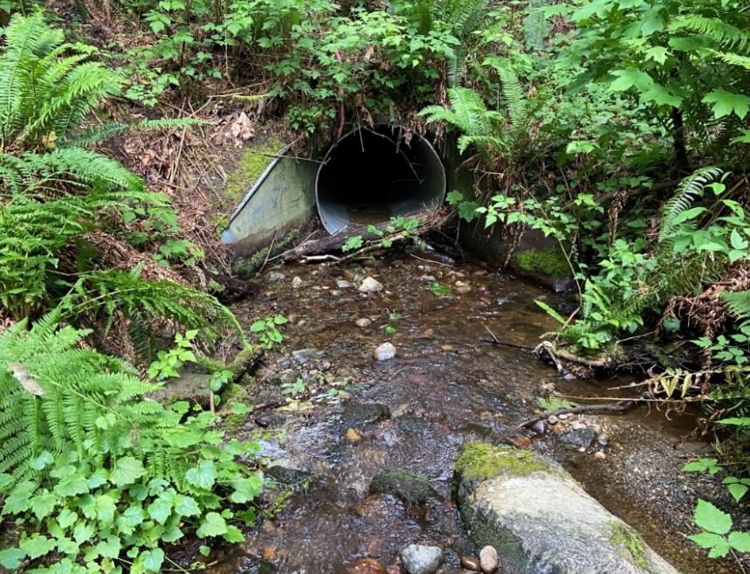
Example photo, replace with project photo(s).

[Existing features (e.g., [X]-foot diameter/span pipe)]
[Name Creek/River]
Figure 2 Existing [I/US/SR] [XX] MP [XX] [Project Site Location (e.g., Culvert)]
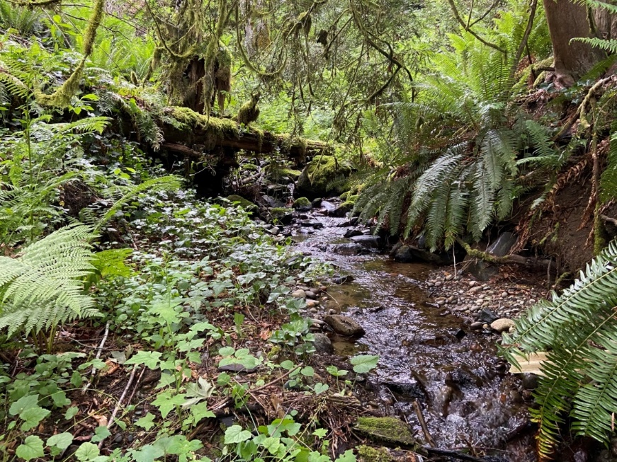
Example photo, replace with project photo(s).

[Name Creek/River]
Figure 3 Upstream Reach Conditions
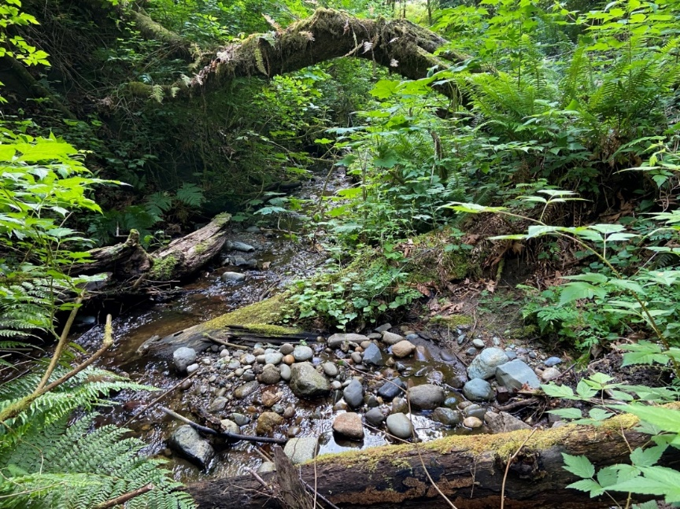
Example photo, replace with project photo(s).

[Name Creek/River]
Figure 4 Downstream Reach Conditions
Definition of structures (FEMA CFR 44 §9.4): "walled or roofed buildings, including mobile homes and gas or liquid storage tanks"

[Describe the reach and any parcels with structures (e.g., downstream of the [I/US/SR] [XX] crossing, [Name Creek/River] has historically downcut into the underlaying glacial recessional material, thereby creating a terrace on its left overbank area. A private property is located on this terrace that is, at a minimum, [XX] feet above the present creek bed (Figure 5).]
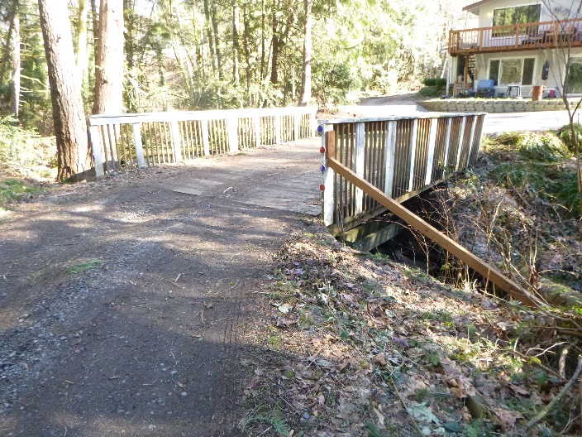
Example photo, replace with project photo(s).

[Name Creek/River]
[Specify Property]
Figure 5 [Specify Property] Roughly [XX] Feet [location (e.g., Downstream)] of [I/US/SR] [XX] MP [XX]

Data Compilation

Effective Model
Contact WSDOT to obtain FEMA effective data:
Luke Assink, P.E., WSDOT Hydraulics
Office Phone (360) 705-7269
Cell Phone (509) 307-6092
AssinkL@wsdot.wa.gov
[Choose one of the following to describe the FEMA requirements:]
[(1) If the effective model available in electronic format:]
[Specify WSDOT or firm name] obtained the effective [specify model type/software/version (e.g., one-dimensional (1D) HEC-RAS v6.3.1; one-dimensional (1D) HEC-2, etc.)] hydraulic model used in developing the FIRM[s]. [Describe the origin of the effective data (e.g., developed by, date developed, effective date, etc.)]. The effective data, provided in Attachment C, was used to develop the duplicate effective model (Section 2.3.1).
[(2) If effective data is only available in PDF format:]
[Specify WSDOT or firm name] obtained the effective [specify model type (e.g., HEC-2)] model in PDF format (Attachment C). The effective model was used in developing the effective FIRM[s] Panel No[s]. [XXXXXXX]. [Describe the origin of the effective data (e.g., developed by, date developed, effective date, etc.)]. The PDF containing [specify model type (e.g., HEC-2)] data was submitted as the duplicate effective model, per FEMA guidelines (FEMA 2022b). As effective modeling files are not available, duplicate effective (Section 2.3.1) and corrected effective (Section 2.3.2) modeling files are not required for this project, per FEMA guidelines (FEMA 2022b).
[(3) If effective data is not available for the project:]
Effective data is not available for this reach. [Describe reasoning (e.g., project not mapped in a FEMA flood hazard zone; effective data not available from FEMA’s library (include data request documentation in Attachment C)]. As effective data is not available, duplicate effective (Section2.3.1) and corrected effective (Section 2.3.2) models are not required for this project, per FEMA guidelines (FEMA 2022b).

Terrain Data
[Describe all terrain data used in the no-rise analysis. The following may be included, as applicable:]
- [Effective terrain data. State the effective vertical datum; if datum differs from Section 2, provide datum conversion information from the NGS Coordinate Conversion and Transformation Tool (NCAT) in Attachment C.
- Field survey data. Describe agency/consultant who performed survey, the survey date (month day, year) and survey extents. The survey shall be certified/stamped by a Professional Land Surveyor (PLS) or a licensed engineer representing the agency responsible for the survey, registered in the State of Washington; indicate accordingly. Field survey limits shall include longitudinal extents (upstream and downstream) for a proper downstream boundary condition and upstream convergence of the water surface elevation profile; proper lateral extents shall span the inundation limits. As this is a 1D analysis, a complete digital elevation model (DEM) may not be required; cross sectional data may be sufficient.
- LiDAR data. Describe source of data, include the LiDAR collection date (month, year) and accuracy of data (QL1, QL2, etc.).
- Discrepancies between effective and current (existing) terrain sources; discuss tie-in challenges, if observed. Provide figure(s) to illustrate tie-in challenges.
- Proposed conditions data. Describe proposed terrain development; specify agency/consultant who developed the proposed surface; describe the design phase and date (month, year). Reference Attachment B.]

Hydrologic Data
[Description of hydrologic data (peak or unsteady flow) used in the no-rise analysis. Include references and/or methodology, as applicable. Choose one of the following to describe 1-percent AEP (100-year) flood flow(s):]
[(1) If in a SFHA with a detailed study and the 1-percent AEP (100-year) flood flow used for FEMA] The FEMA 1-percent AEP (100-year) flood flow of [XXX] cfs (FEMA, [XXXX]) is used in the no-rise analysis presented in Section 2. [Include citations for applied hydrologic data (e.g., effective FIS, preliminary FIS data, etc.)]. The [type (e.g., peak or unsteady)] flow data is summarized in [for steady-state peak flow, reference Table 1; for unsteady flow, reference Figure 6].
[(2) If in a SFHA with no detailed study or not in a SFHA] The 1-percent AEP (100-year) flood flow of [XXX] cfs is used in the no-rise analysis presented in Section 2. The supporting hydrologic calculations are provided in Attachment D. [Include a description of hydrologic data development, including software type and version; include citations for applied hydrologic data (e.g., external studies)]. The [type (e.g., unsteady, peak)] flow data is summarized in [for steady-state peak flow, reference Table 1; for unsteady flow, reference Figure 6].
[Use Table 1 or Figure 6, based on hydrology type; delete unused table/figure]:
Table 1 [I/US/SR] [XX] MP [XX] [Name Creek/River] Summary of Peak Flow Hydrology used for the No-Rise Analysis
Flooding Source and Location [include section Station or Letter Designation]  Add additional rows if there is a change in flow in the modeled reach. | 1-Percent AEP Peak Flow (cfs)

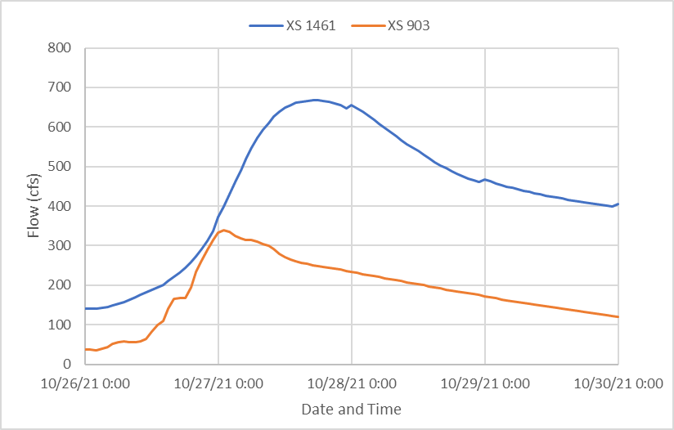
Example hydrograph, replace with project hydrograph (if required).
Figure 6 [I/US/SR] [XX] MP [XX] [Name Creek/River] Summary of Unsteady Hydrograph(s) used for the No-Rise Analysis

Model Development
The no-rise analysis for [I/US/SR] [XX] MP [XX] [Name Creek/River] was performed using a [specify model type/software/version (e.g., one-dimensional (1D) HEC-RAS v6.3.1)] hydraulic model [(Add Reference)]. [Specify the number of condition models referred to below that were used] conditions were analyzed in determining no-rise compliance: [Describe the conditions models used in the no-rise analysis (e.g., (1) duplicate effective; (2) corrected effective (3) existing conditions; and (4) proposed conditions)]. The following sections describe the model development in detail.

Duplicate Effective Model
[Describe if a duplicate effective model was used in the no-rise analysis and reference the effective data obtained in Section 2.2.1. If a duplicate effective model was not used in the no-rise analysis, describe the reasoning. Reference Guidance Document 106 (Section 2.5.2 and Figure 2) (FEMA 2022b) for a description of the duplicate effective model.]
[If a duplicate effective model is used, describe the model limits (reference Figure 1) and any updates required to convert the effective model to the duplicate effective model. Describe how closely it matches water surface elevations from the effective model or FIRM (if applicable); if needed, compare duplicate effective results with the effective model and provide summary tables in Attachment E. Restate the vertical datum of the effective model, and if any datum conversions were applied to compare WSE results in this report; reference Section 2.2.1 for effective data and Attachment C for datum conversion documentation. Reference hydrologic inputs in Section 2.2.3. Describe how the duplicate effective model was applied in the analysis (e.g., a basis for the corrected effective model).]

Corrected Effective Model
[Determine if the no-rise analysis requires a corrected effective model; reference Section 2.5.2 of Guidance Document 106 (FEMA 2022b). Per guidance documentation, the corrected effective model must not reflect any manmade physical changes that have occurred since the date of the effective published study (if applicable). Describe the model limits, reference FEMA sections, if applicable, and reference Figure 1. Describe any model corrections or modifications. In some cases, the corrected effective model is the existing conditions model; if so, state in this section and reference the existing conditions model in Section 2.3.3. If a corrected effective model was not used in analysis, describe the reasoning.]

Pre-Project (Existing) Conditions Model
[Describe how the existing conditions model was developed; reference Section 2.5.2 of Guidance Document 106 (FEMA 2022b) and sections of this report, as applicable. The existing conditions model incorporates new terrain data and reflects physical modifications that have occurred within the floodplain since the date of the effective FIS, but prior to the construction of the project.]. [Describe the limits of model updates (and reference FEMA cross sections, if applicable), reference locations in Figure 1. Describe existing conditions terrain and vertical datum (Section 2.2.2). Describe flow inputs (Section 2.2.3). Describe any model corrections or modifications. If additional cross sections were added for the proposed conditions model (because of terrain or local agency regulations), those should also be discussed in this section so a 1:1 comparison can be made between the models. Include why they were added as well as which cross sections are new.]. The hydraulics through the existing [describe existing project features/conditions (e.g., X-foot corrugated metal pipe (CMP) with metal wingwalls that conform to the surrounding ground, X-span bridge, bank protection, habitat restoration, etc.)] were computed using [specify model type and version (e.g., HEC-RAS, version 6.3.1)] [(USACE, XXXX)]. Manning’s n values in the channel range from [0.XXX] to [0.XXX] while values ranging from [0.XXX] to [0.XXX] were used to represent roughness on the floodplain. [Provide additional description, as necessary.]. Existing conditions model results are provided in Attachment F.

Post-Project (Proposed) Conditions Model
The proposed conditions model was developed based on [describe how the proposed model was developed (e.g., the existing conditions model); reference Section 2.5.2 of Guidance Document 106 (FEMA 2022b) and sections of this report, as applicable]; model geometry was modified to represent the proposed [describe proposed project features/conditions (e.g., channel grading, large woody material (LWM), engineered log jam (ELJ),bank protection, etc.)]. The proposed conditions terrain (Section 2.2.2) was used to represent the post-project geometry of the [Name Creek/River]; floodplain; and [I/US/SR] [XX] roadway embankments and structure. The WSDOT proposed project also includes [describe proposed project]. [Describe associated project elements and reference the FHD (or other report type) ()] (Attachment B). [Describe the modified model limits in Figure 1, relate to FEMA Sections, if applicable.] Manning’s n values, in areas where no grading is expected to occur, matched the existing conditions. In the areas of the proposed project, Manning’s n values in the channel range from [0.XXX to 0.XXX] while values ranging from [0.XXX to 0.XXX] were used to represent roughness on the floodplain. [Provide additional description, as necessary.]. Proposed conditions model results are provided in Attachment F.

Modeling Results

Floodplain Model Water Surface Elevation Comparison
Table 2 compares the floodplain model 1-percent AEP (100-Year) water surface elevations for the [describe comparison events (e.g., proposed and existing and/or effective conditions models)]. As shown in Table 2, the results indicate the proposed project does not create a rise in the 1-percent AEP (100-Year) floodplain water surface elevations and thus meets the [describe criteria (e.g., FEMA, Community Name(s))] no-rise criteria. [Reference Attachment F if additional results are included.].
Number of comparison locations will vary depending on project. Need sufficient number of comparison locations to capture project effects. A second table will be necessary if local regulations require existing AND effective model comparisons.
Table 2 [I/US/SR] [XX] MP [XX] [Name Creek/River] 1-Percent AEP (100-Year) Floodplain Model Water Surface Elevation Comparison
Cross-Section Station | Cross Section [FEMA Letter Designation / Description] | [Existing/Effective] Water Surface Elevation (Feet, NAVD88) | Proposed Water Surface Elevation (Feet, NAVD88) | Difference (Feet)
[XX] | [X] | [XXX.XX] | [XXX.XX]  If no Effective data, only provide cross section description. | [X.XX]
[XXX*] | Interpolated | [XXX.XX] | [XXX.XX] | [X.XX]
[XXX] | [-] | [XXX.XX] | [XXX.XX] | [X.XX]
[XXX*] | Interpolated | [XXX.XX] | [XXX.XX] | [X.XX]
[XXX] | [X] | [XXX.XX] | [XXX.XX] | [X.XX]
[XXX] | [-] | [XXX.XX] | [XXX.XX] | [X.XX]
[XXX] | [SR XX] MP [XX]
[XXX] | [-] | [XXX.XX] | [XXX.XX] | [X.XX]
[XXX] | [-] | [XXX.XX] | [XXX.XX] | [X.XX]
[XXX] | [-] | [XXX.XX] | [XXX.XX] | [X.XX]
[XXX] | [X] | [XXX.XX] | [XXX.XX] | [X.XX]
[XXX] | [[-] | [XXX.XX] | [XXX.XX] | [X.XX]
[XXX] | [-] | [XXX.XX] | [XXX.XX] | [X.XX]
[XXX] | [-] | [XXX.XX] | [XXX.XX] | [X.XX]
[XXX] | [X] | [XXX.XX] | [XXX.XX] | [X.XX]
[XXX] | [-] | [XXX.XX] | [XXX.XX] | [X.XX]
[XXX] | [-] | [XXX.XX] | [XXX.XX] | [X.XX]
[XXX] | [X] | [XXX.XX] | [XXX.XX] | [X.XX]
* Represents Interpolated Sections
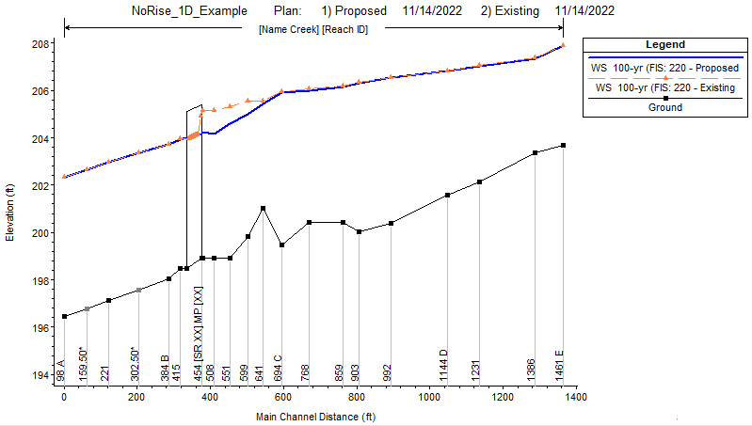
Example WSE profile comparison of proposed to existing conditions, replace with project model results. If using existing model, add effective elevations to the profile at each FEMA cross section for reference. Check with local floodplain coordinators for additional information (e.g., King County likes to see bank elevations on this figure) needs.
Figure 7 [I/US/SR] [XX] MP [XX] [Name Creek/River] 1-Percent AEP (100-Year) [describe comparison events (e.g., Proposed and Existing Conditions Models)] Floodplain Model Water Surface Elevation Profile Comparison
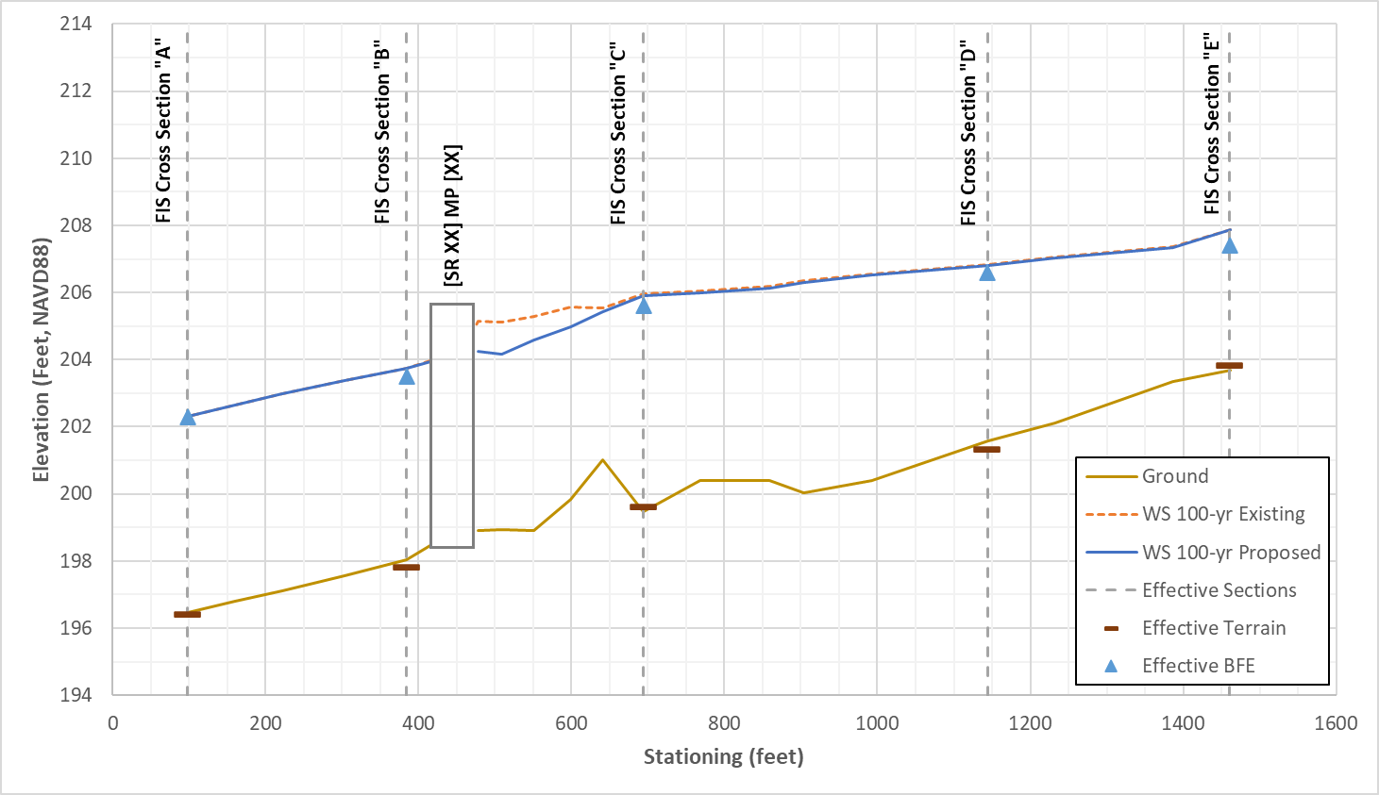
A plot similar to this will need to be created in excel showing existing/proposed WSE and ground elevations in addition to effective cross section locations, terrain points, and cross section BFEs.

Floodway Model Water Surface Elevation Comparison (if applicable)
Important for designer to coordinate with local community to find out if no-rise should be based on effective or existing conditions and whether the floodplain and/or floodway models need to be analyzed. If the local community has no preference, designs will be based on existing condition using the floodplain model.
Table 3 compares floodway model 1-percent AEP (100-year) water surface elevations for the [describe comparison events (e.g., proposed and existing conditions models).]. As shown in Table 3, the results indicate the proposed project does not create a rise above 0.00 feet in the floodway water surface elevations and thus meets the [describe criteria (e.g., FEMA, Community Name(s))] no-rise criteria. [Describe surcharge for models]. [Reference Attachment F if additional results are included.].
Table 3 [I/US/SR] [XX] MP [XX] [Name Creek/River] 1-Percent AEP (100-Year) Floodway Model Water Surface Elevation Comparison]
Cross-Section Station | Cross Section FEMA Letter Designation/Description | Existing/Effective Water Surface Elevation (Feet, NAVD88) | Proposed Water Surface Elevation (Feet, NAVD88) | Difference (Feet)
[XX] | [X]  Number of comparison locations will vary depending on project. Need sufficient number of comparison locations to capture project extents. | [XXX.XX] | [XXX.XX] | [X.XX]
[XX] | [X] | [XXX.XX] | [XXX.XX] | [X.XX]
[XX] | [X] | [XXX.XX] | [XXX.XX] | [X.XX]
[XX] | [X] | [XXX.XX] | [XXX.XX] | [X.XX]
[XX] | [X] | [XXX.XX] | [XXX.XX] | [X.XX]
[XX] | [X] | [XXX.XX] | [XXX.XX] | [X.XX]

Summary of No-Rise Analysis
The simulated proposed [I/US/SR] [XX] MP [XX] [Name Creek/River] [describe proposed project features/conditions (e.g., channel grading, large woody material (LWM), engineered log jam (ELJ),bank protection, etc.)] [Describe associated project elements ()] does not cause a rise in the 1-percent AEP (100-Year) water surface elevation calculated by the [describe model types (e.g., floodplain, floodway)] model (Section 2.4). A signed no-rise Certification form is provided in Attachment H. The project, therefore, meets the no-rise criteria following [describe meeting FEMA minimum requirements and/or local Community criteria; reference Section 1.2 and Section 1.3 (e.g., 44 CFR §60.3, Community Name(s)/code section(s) XX.XX.XX, etc.); reference Attachment G. If local Community requirements are not applicable, state in this section.].
Attachment G includes local Community forms, such as: Community certification letters, compensatory storage forms, etc.
If you have any questions or need further assistance regarding the information included in this memorandum, please feel free to contact Julie Heilman at heilmaj@wsdot.wa.gov / (360) 705-7262, or [name of author(s)] [author(s) emails].

cc: [Add cc recipients]
HQ Hydraulics File

References
[These are suggested references and are not inclusive of all references that may or may not be used. Add and remove references as appropriate for each individual no-rise analysis. Update with appropriate FEMA and local Community code references]
Chow, V.T. 1959. Open Channel Hydraulics, McGraw-Hill book Company, NY.
USACE (United States Army Corps of Engineers). [2022]. HEC-RAS River Analysis System [v.6.3.1].
USACE. [1991]. Hydrologic Engineering Center, HEC-2 Water Surface Profiles Generalized Computer Program, Davis, California, [September 1991].
FEMA (Federal Emergency Management Agency). XXXX. Flood Insurance Study, [Community ID, Washington, Unincorporated Areas]. Flood Insurance Study Number [XXXXXXXXXX]. Dated: [Month Day, Year].
FEMA. [XXXX]. National Flood Insurance Program, Flood Insurance Rate Map for [Community ID, Washington]. Map number[s] [XXXXXXXX].
FEMA. 2021a. Guidance for Flood Risk Analysis and Mapping: Floodway Analysis and Mapping, Guidance Document 79.
FEMA. 2022b. Guidance for Flood Risk Analysis and Mapping: MT-2 Requests, Guidance Document 106.
WSDOT (Washington State Department of Transportation). 2023. Hydraulics Manual. Olympia, Washington. Publication M 23-03.09.

Attachments
[Do not revise Attachment lettering to keep consistency with no-rise memos. If an Attachment is not used, simply add a note to the fly sheet that it was not used or is not applicable to this analysis. Add additional Attachments below the standard list if needed.]
Attachment A: FEMA FIRM
Attachment B: Stream Plan Sheets, Profile, Details
Attachment C: Effective Model Data
Attachment D: Hydrologic Data [Optional]
Attachment E: Effective and Duplicate Effective Model Comparison [Optional]
Attachment F: Model Results [as applicable (e.g., Duplicate Effective, Corrected Effective, Existing Conditions, Proposed Conditions); include electronic model files, when available]
Attachment G: Local Community Requirements [(e.g., community certification forms, compensatory storage, etc.)]
Attachment H: Signed No-Rise Certification Form

Attachment A: FEMA FIRM
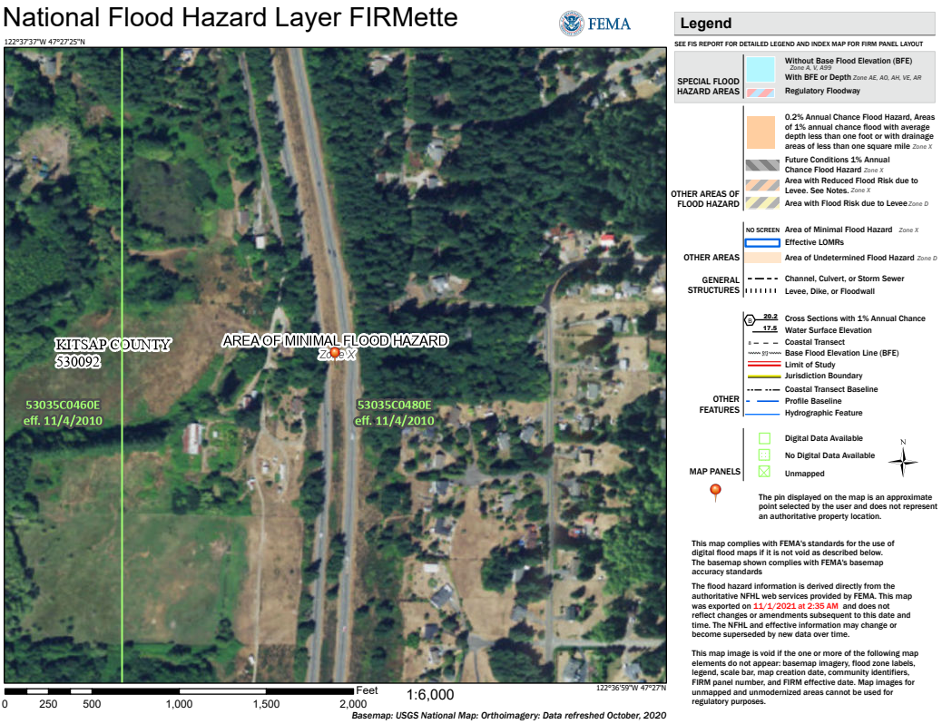
Example figure, update with project site FIRM/FIRMette. Include an arrow pointing to the project site.
Project Site

Attachment B: Stream Plan Sheets, Profile, Details

Attachment C: Effective Model Data
[If the effective data is available in PDF format, include PDF input/output in this section. If the effective model is available in electronic format, include electronic model files with the submission. If applicable, provide vertical datum conversion documentation; use the NGS Coordinate Conversion and Transformation Tool (NCAT). If effective data is not available or not applicable, add a description to this fly sheet.]

Attachment D: Hydrologic Data and Analysis [Optional]
[Include hydrologic data and analysis in this section; if hydrologic data is not applicable, add a description to this fly sheet.]

Attachment E: Effective and Duplicate Effective Model Comparison [If, applicable]
[Include effective vs. duplicate effective comparison table; see example below. If not applicable, add a description to this fly sheet. Include electronic model files with submission.]

Reach | Cross-Section Station | Description | Profile | Water Surface Elevation (Feet, NAVD88) |  | Top Width (Feet)
 |  |  |  | HEC-RAS | HEC-2 | HEC-RAS | HEC-2
[Name Creek] – [Reach ID] | [XX] | [X] | [100-Year FIS] | [XXX.XX] | [XXX.XX] | [XX.X] | [XX.X]
 | [XXX] | [-] |  | [XXX.XX] | [XXX.XX] | [XX.X] | [XX.X]
 | [XXX] | [X] |  | [XXX.XX] | [XXX.XX] | [XX.X] | [XX.X]
 | [XXX] | [-] |  | [XXX.XX] | [XXX.XX] | [XX.X] | [XX.X]
 | [XXX] | [I/US/SR XX] MP [XX] |  | [Bridge/Culvert/ Other] | [Bridge/Culvert/ Other] | [Bridge/Culvert/ Other] | [Bridge/Culvert/ Other]
 | [XXX] | [-] |  | [XXX.XX] | [XXX.XX] | [XX.X] | [XX.X]
 | [XXX] | [-] |  | [XXX.XX] | [XXX.XX] | [XX.X] | [XX.X]
 | [XXX] | [-] |  | [XXX.XX] | [XXX.XX] | [XX.X] | [XX.X]
 | [XXX] | [-] |  | [XXX.XX] | [XXX.XX] | [XX.X] | [XX.X]
 | [XXX] | [-] |  | [XXX.XX] | [XXX.XX] | [XX.X] | [XX.X]
 | [XXX] | [X] |  | [XXX.XX] | [XXX.XX] | [XX.X] | [XX.X]
 | [XXX] | [-] |  | [XXX.XX] | [XXX.XX] | [XX.X] | [XX.X]
 | [XXX] | [-] |  | [XXX.XX] | [XXX.XX] | [XX.X] | [XX.X]
 | [XXX] | [-] |  | [XXX.XX] | [XXX.XX] | [XX.X] | [XX.X]
 | [XXX] | [-] |  | [XXX.XX] | [XXX.XX] | [XX.X] | [XX.X]
 | [XXX] | [X] |  | [XXX.XX] | [XXX.XX] | [XX.X] | [XX.X]
 | [XXXX] | [-] |  | [XXX.XX] | [XXX.XX] | [XX.X] | [XX.X]
 | [XXXX] | [-] |  | [XXX.XX] | [XXX.XX] | [XX.X] | [XX.X]
 | [XXXX] | [X] |  | [XXX.XX] | [XXX.XX] | [XX.X] | [XX.X]

Attachment F: Model Results
[Include model output, such as cross sections (see examples below). Include electronic model files with submission.]

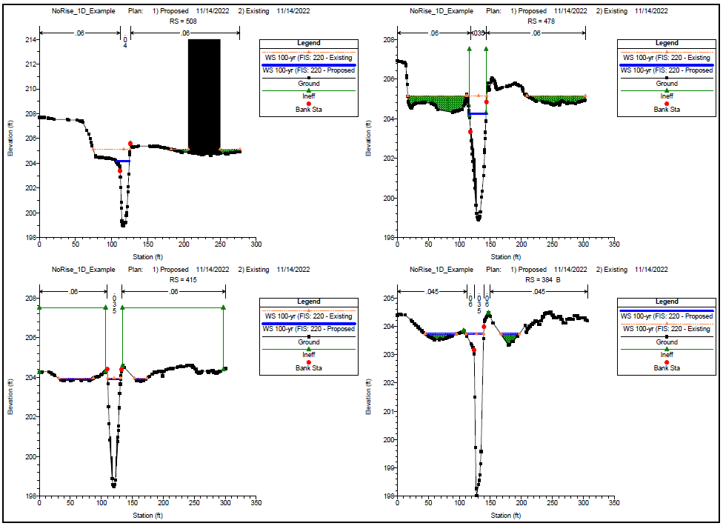
Example cross-sections figures. Replace with sufficient number of cross sections for the project.
Figure E.2 Cross-Sections and Computed Water Surface Elevations for [describe comparison events (e.g., Proposed and Existing Conditions Models)]

Attachment G: Local Community Requirements
INTERNAL - Review the DRAFT floodplain regulation database for local Community requirements, based on the mapped zones: DRAFT_Floodplain Development Regulation_Database_2022.06JUNE.30.xlsx
*Note, check Community code directly to ensure there are no additional requirements
EXTERNAL - Check Community code directly to ensure there are no additional requirements above FEMA minimum standards.
Contact WSDOT for additional assistance:
Luke Assink, P.E., WSDOT Hydraulics
Office Phone (360) 705-7269
Cell Phone (509) 307-6092
AssinkL@wsdot.wa.gov

[This section includes local Community forms, such as: Community certification letters, compensatory storage forms, etc.]

Attachment H: Signed No-Rise Certification Form

ENGINEERING "NO-RISE" CERTIFICATION

Community: County: State: WA
Applicant: Date:
Engineer:
Address:
Telephone:
Address:
Telephone:

SITE DATA:
- Location: 1/4; 1/4; Section ; Range ; Township:

- Street Address:

- Panel(s) No. of NFIP map(s) affected:

- Type of development: Filling Grading Habitat Enhancement Substantial-Improvement New Construction Other

- Description of Development:

- Name of flooding source:

- Comments:

This is to certify that I am a duly qualified engineer licensed to practice in the State of Washington. It is to further certify that the attached technical data supports the fact that the proposed development described above will not create any increase to the 1-percent annual exceedance probability (AEP) (100-year) elevations on said flooding source above at published cross sections in the Flood Insurance Study for the above community dated and will not create any increase to the 1-percent AEP (100-year_ flood elevations at unpublished cross-section in the vicinity of the proposed development.

Name:
Signature: Date: (Seal)
Title: License No.:

